1. A working GUI tkinter application with at least two windows.   50 points
   1. I have two windows. One the event page and second the contact us page.
2. Implementing a modular approach in your application. 10 points
3. Consistent clear navigation throughout the GUI application.   10 points
4. Use at least two images in your application (images should have alternate text).  10 points
   1. The border event planner image.
   2. Thank you, image that pops, up when you successfully save event.
5. Include at least three labels. 10 points
   1. Event name label,
   2. Event date label
   3. Event time label
   4. Location label.
6. Include at least three buttons. 10 points
   1. Choose date button
   2. Choose time button
   3. Save event button
   4. Exit button.
7. Include at least three call back function with each button, including exit button. 20 points
   1. Choose date button have a call back function: cancel
   2. Choose time button have a call back function: cancel
   3. Save Event: okay
   4. Exit button
8. Implement secure coding best practices, including input validation to check if the user entered the correct data type, make sure the entry box is not empty, etc.   10 points
   1. User has to fill all the entry box or an error message would pop up. The date and time have to be entered in a specific format.
9. Validation testing - 20 points.  Develop an appropriate set of test data to fully validate the program against.
   1. the data sets you tested against.
10. **Case: Valid Event**

* Event Name: Birthday Party
* Event Date: 2023-12-25
* Event Time: 15:30
* Location: My House

1. **Case: Empty Event Name**

* Event Name: (empty)
* Event Date: 2023-12-25
* Event Time: 15:30
* Location: My House

1. **Case: Invalid Date Format**

* Event Name: Wedding
* Event Date: 25-12-2023
* Event Time: 18:00
* Location: Beach

1. **Case: Missing Event Time**

* Event Name: Conference
* Event Date: 2023-10-15
* Event Time: (empty)
* Location: Convention Center
  1. a brief written explanation of the results of your tests and what you had to fix.

1. **Valid Event:**

* Success message displayed.
* Features logo pop-up appears.

1. **Empty Event Name:**

* Error message displayed, prompting to fill in all fields.

1. **Invalid Date Format:**

* Error message displayed, prompting to use YYYY-MM-DD format.

1. **Missing Event Time:**

* Error message displayed, prompting to fill in all fields.
  1. screen shots of your good test data working.

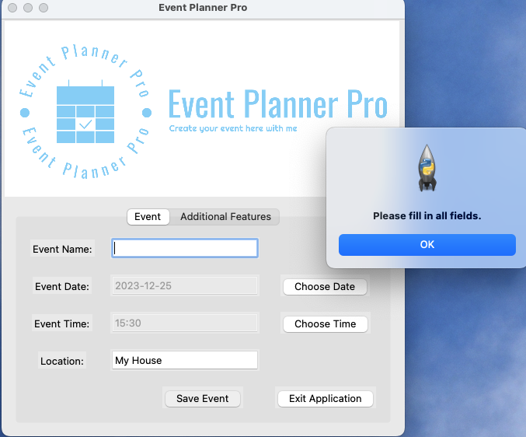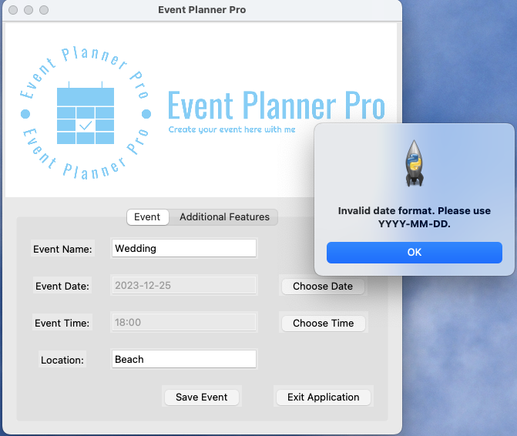

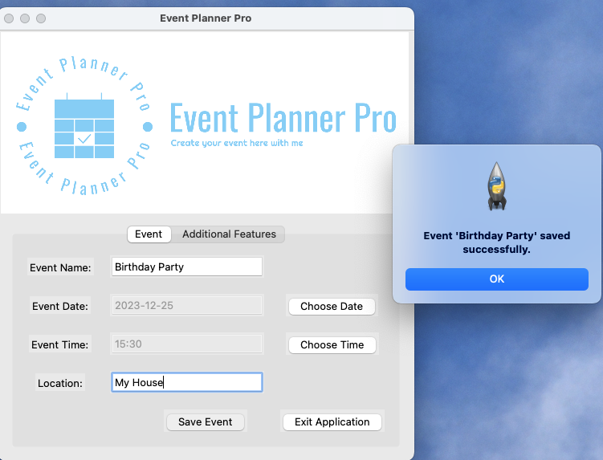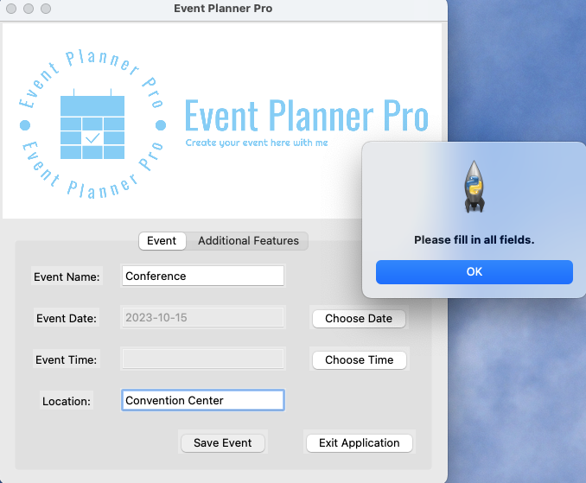

1. User manual creation - 20 points.  You will write and submit a user’s manual for your final project and submit it according to the instructions in the attached file.
2. **Getting Started:**

* Launch the application by executing the script.
* The main window displays the event logo and two tabs: "Event" and "Additional Features."
* Navigate between tabs using the notebook.

1. **Event Tab:**

* Fill in the event details:
* Event Name
* Event Date (Use the "Choose Date" button)
* Event Time (Use the "Choose Time" button)
* Location
* Click "Save Event" to save the event.
* Click "Exit Application" to close the app.

1. **Contact Us**

* This tab is for users to have our contact information.

1. **Saving Events:**

* Ensure all fields in the "Event" tab are filled.
* Click "Save Event."
* If successful, a success message appears, and the features logo pop-up is displayed.

1. **Date and Time Selection:**

* Use the "Choose Date" and "Choose Time" buttons to set the event date and time.

1. **Exiting the Application:**

* Click "Exit Application" to close the program.

1. Documentation of source code - 20 points.  You will fully document (comment) the corrected Python tkinter source code with appropriate comments including:
2. A brief explanation of the purpose of each module (Sub) at the beginning of each Sub. (A header's comment)
3. Explanation of the purpose of each variable where it is declared. (An end line comment)
4. Line by line, or at least section by section comments within the code, explaining what the line/section does.
5. The link of the GitHub repository for your final project. 10 points
6. https://github.com/Judyng553/SDEV140-Final-Project.git